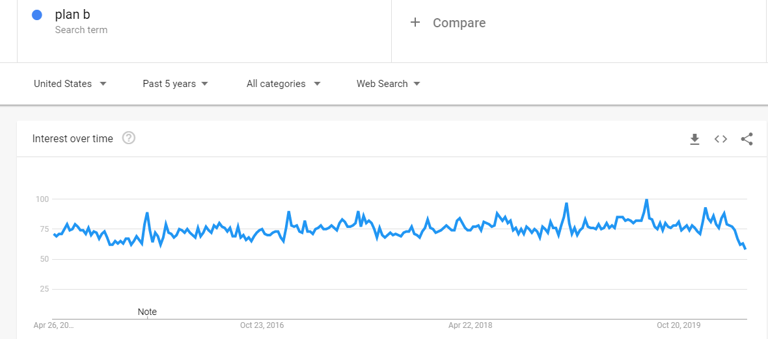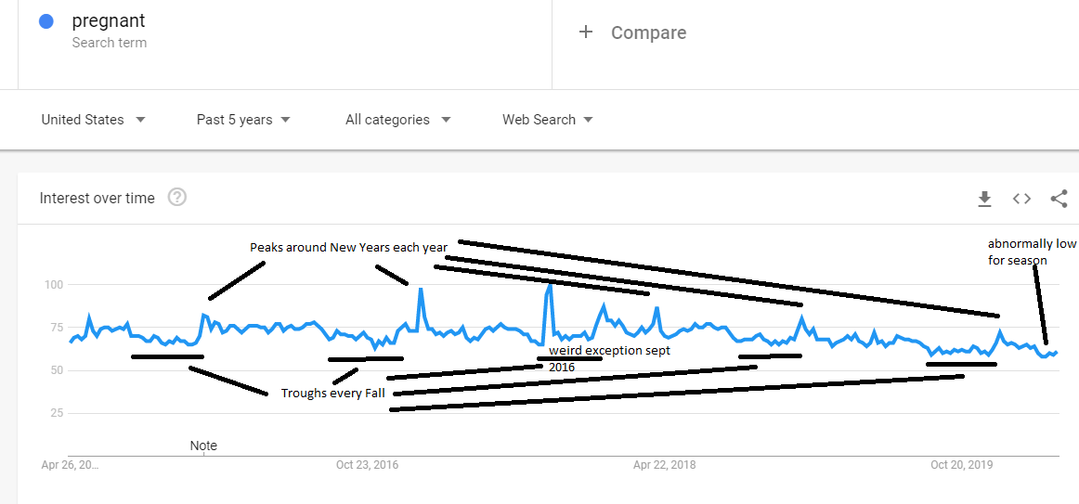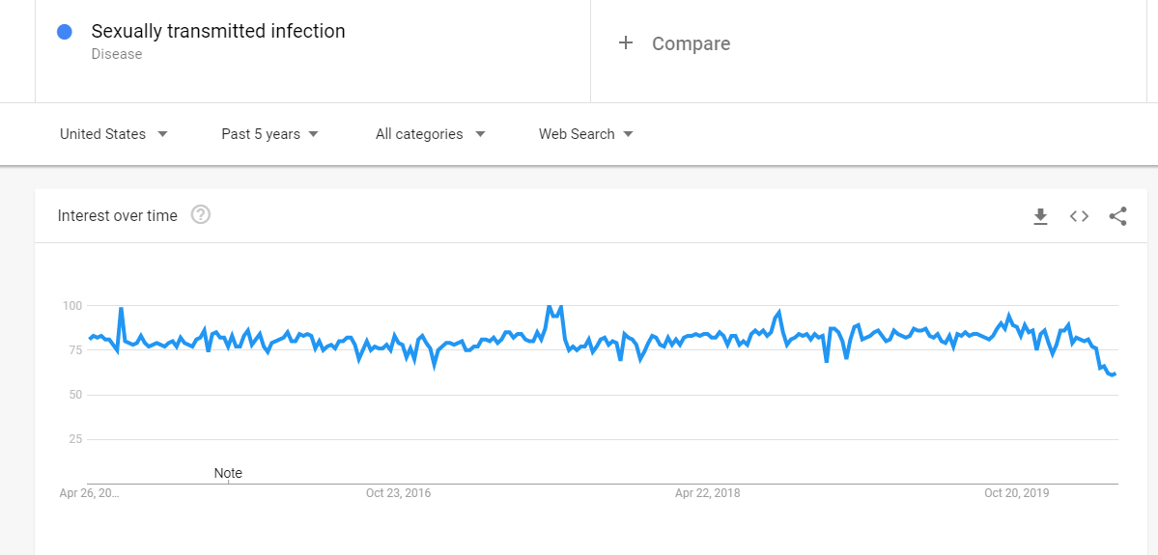

Paper we can use to estimate fraction of births which are unintended

<https://www.nber.org/papers/w25521.pdf>

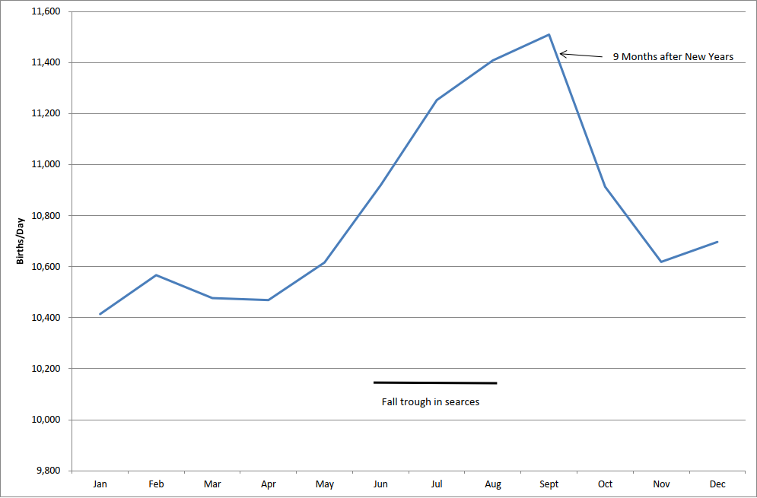

From Buckles and Hungerman (2013) – Inverse relationship between maternal education and number of births in that month.